

Name : Uvannithan Sivamurugan

Login ID :uvannithan@oasis-portal.com

Course title : Executive Diploma in Culinary Arts & Hospitality Management

Subject Code : CA03 International cuisine

Submitted date: 7th /September/ 2017

**Table of Contents**

|  |  |  |
| --- | --- | --- |
| **No** | **Details** | **Page** |
| 1 | Executive Summary | 2 |
| 2 | Introduction | 3 |
| 3 | Assignment Question |  |
|  | Part 1 | 4-6 |
|  | Part 2 | 7-10 |
|  | Part 3 | 11-13 |
|  | Part 4 |  |
| 4 | Conclusion | 14 |
| 5 | References | 15 |

**Executive Summary**

In this assignment, we will learn about the purpose of this unit that is to be able to understand international cuisine within culinary art and hospitality management.

We will need to choose one dish from each cuisine .he cuisine are Chinese, western and Indian cuisine .from each cuisine, we will need to recreate or alter the original recipe into our own recipe.

From doing this assignment, I learn that Chinese cuisine, Indian cuisine, and western cuisine got a lot of different in cooking, using ingredient and also plating .There also got a lot of cuisine in this world. Example of the cuisine are:-

Chinese cuisine:-

=Dumpling

=Chinese fried rice

=Garlic soya chicken

=Wan ton me

Indian cuisine

=chicken tikka masala

=tandoori chicken

=biryani

Western cuisine

=duck confit

=American heart breakfast

=chili crab pasta

**Introduction**

In light of the importance of increased globalization, the need for a comprehensive guide to the many varied cuisines of the world is more important than ever. **International Cuisine** by The International Culinary Schools at The Art Institutes serves as a window for students, professional chefs, and serious home chefs, alike, to explore the different cultures and cuisines of the world. While there are numerous cookbooks devoted to a particular country or region (such as Italy or Latin America), this book brings together the world's regions in one complete source.

International Cuisine shows how the history, geography, religion and, of course, the ingredients of a particular region/country/area influence different cuisines. Some chapters discuss one country individually, while others include two or more combined. The effort was to select countries that are culinary representatives to the world. For instance, entire chapters are devoted to Mexico, China, Spain, France, and Italy, while regions such as the Caribbean, the Middle East, and Scandinavia are grouped together.

**Question 1**

**You should create your own dish from each international cuisine listed.**

**Choose one dish for each cuisine:**

**Chinese cuisine**

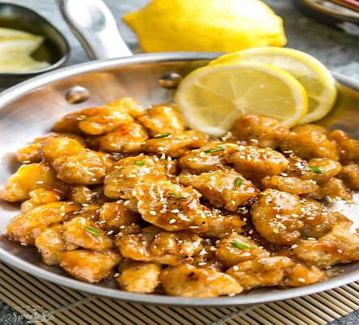

**Lemon chicken**

**Ingredient**

1 egg white, lightly beaten

1 lb. boneless skinless chicken breast, cut into bite-sized chunks (or long strips if preferred)

1/2 cup corn-starch

1/3 cup panko crumbs (use gluten free if necessary or leave out)

1 teaspoon salt

1/4 teaspoon black pepper

Oil, for pan-frying

**For the sauce**

1/2 cup low sodium soy sauce

1/4 cup honey

2 tablespoons rice wine vinegar (or 1 tablespoon apple cider vinegar)

3 tablespoons fresh squeezed lemon juice

1 tablespoon lemon zest

1 teaspoon sesame oil

2 cloves garlic, finely minced (or 1 teaspoon garlic powder)

1/2 teaspoon freshly grated ginger

2 tablespoons corn-starch

2-3 tablespoons water, plus more to thin out sauce

1 teaspoon Sriracha hot sauce, optional or to taste

Instruction

1. Combine the sauce ingredients together in a medium saucepan. Measure out 3 tablespoons and add to a large mixing bowl. Set aside the saucepan. To the mixing bowl, lightly beat in the egg white and add chicken pieces. Mix well.
2. In a large zip-top freezer bag, combine the corn-starch, panko crumbs, salt and black pepper. Add the chicken and shake well to coat.
3. Cook chicken using your preferred method below.
4. While the chicken is cooking, heat saucepan with sauce on medium high. Allow to bubble and thicken while whisking and turn off the heat. Taste and adjust seasonings to what you prefer - add additional lemon for tangier, honey for sweeter and sriracha for spicier, if desired.
5. **For pan-fry stovetop version**
6. Heat 2-3 tablespoons oil (or enough to lightly coat the bottom of the pan) in a large skillet over medium high heat. Working in batches, add chicken and pan fry until golden and cooked through, about 3-5 minutes per side. Transfer to a large platter lined with paper towels. Repeat.
7. Toss chicken together with heated lemon sauce, coating well.
8. Garnish with green onions, sesame seeds and serve immediately with rice or noodles, if desired.
9. **For the baked version:**
10. Preheat oven to 375F. Place chicken in a single layer on a large baking sheet lined with parchment paper. Bake for 15 minutes or until chicken is cooked, flipping once in between. Turn oven to broil for 2-3 minutes or until chicken pieces turn light brown on top and crisp up. Watch your chicken closely so it doesn't burn. Remove chicken from oven and toss together with heated lemon sauce, coating well.
11. Garnish with green onions, sesame seeds and serve immediately with rice or noodles, if desire

**Own recipe**

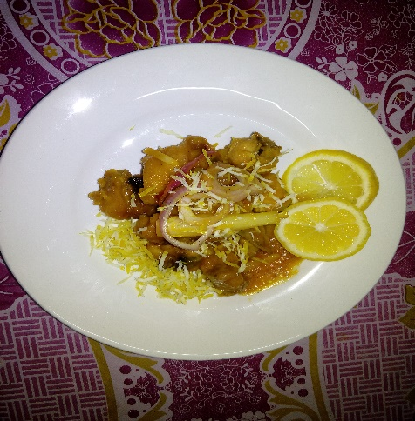

**Lemon chicken**

**Ingredients**

Chicken ½ kg (cut in to small pieces)

Lemon grass 2 pieces

Lemon 3

Onion 3

Garlic (chop)

Ginger

Flour

Pandan leaf

Cooking oil

Orange juice

Honey

Maggi cukup rasa seasoning

Instruction

1. Clean the chicken. And put some of Maggi “cukup” rasa seasoning for the taste and crispy. Marinated in half an hour. After half an hour take the marinate chicken and coat with wheat flour. Dip fry wit medium flame. Until crispy.
2. In a pan, put some oil in pan with medium flame. Put the lemon grass and “pandan” leaf and sautéed until brown n smell. After that put the garlic , ginger and onion stir it.at last put the fry chicken in.pot the orange juice, honey and little bit of sugar.

And the all evenly. The juicy all get into the chicken.no need to boil the juice let it dry. And serve.**Indian Cuisine**

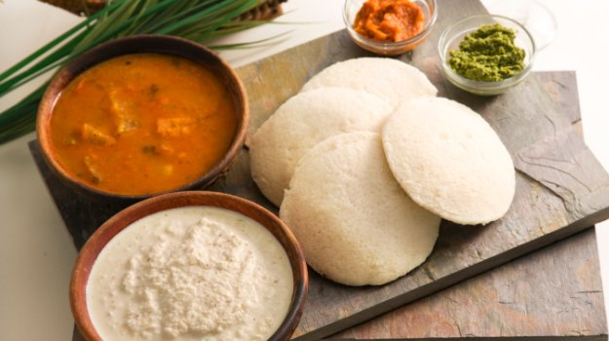

**Idli**

**Ingredient**

1 Cup Urad Dal

4 Cups Idly Rice (1 litter)

2 tablespoon Fenugreek seeds

2 tablespoon Salt

1 Cup Aval or Poha (Optional)

**INSTRUCTIONS**

All the ingredients are soaked for a minimum of 3-4 hours and then ground. Wash all the ingredients in the beginning and then soak it in water. Wash the rice 3-4 times so the idli will be really white later.

Grind the soaked fenugreek seeds in water for 3-4 minutes until they are finely ground and have fluffed up.

Add the soaked and drained urad dal to the wet grinder. Remember the ground fenugreek is still lying in the grinder. Just dump the dal on top of it and add half a cup of water. The tip in grinding urad dal is to add the water slowly. If you add all of the water at once, it won’t fluff up well. The dal should fluff up and fill the grinder. It should have increased about 8-10 times of its original volume. Grind for at least 30 minutes. After 30 minutes, transfer the dal mixture into a bowl and set aside.

Grind the soaked and drained rice for 30 minutes until smooth. Add just enough water while grinding. Once ground, transfer the batter to the dal mixture bowl and mix well.

I add salt to the batter before fermenting in summers and add it after fermenting in winters.

Usually the batter needs to ferment for 8-12 hours.

Once the time is up, the batter should have increased in volume. Take a ladle and mix it well. Your batter is ready.

For the idlies : Put some water in an idly vessel and put it on medium flame. Oil the idli plate and gently fill the rounds with the batter. Put it inside the idly vessel and let it steam for 6-7 minutes. The key to good idlis – Do not allow it to overcook. It might become hard and dry. Just keep an eye and remove the idlis after 6-7 minutes. Do not remove the idlis immediately. It might stick. Leave it undisturbed for 4-5 minutes and then spoon it out. Serve hot with your favourite chutney or sambar.

**Own recipe**

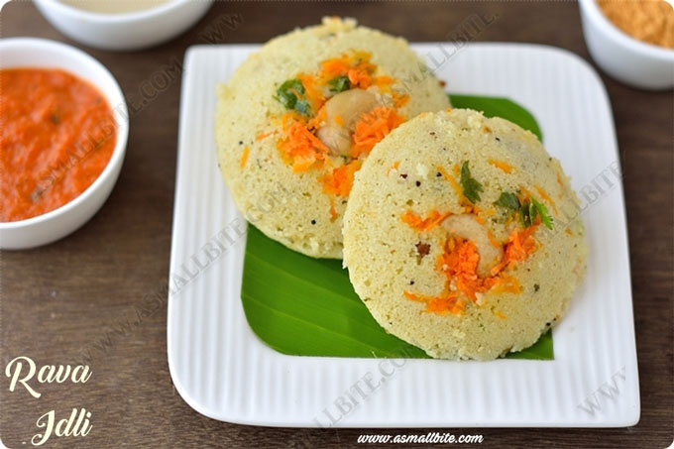

**Rava idli**

**Ingredients**

1 cup semolina

½ teaspoon mustard seeds

½ teaspoon cumin seeds

1 pinch asafetida

1 teaspoon dal

1 teaspoon black split lentils without husk

1-2 spring curry leaves

1 red chili

6-7 cashew nuts, broken into pieces

1/3 cup thick yogurt (curd)

½ cup grated carrot

2 green chili, fined chopped

1 teaspoon grated ginger

1 cup+2 tablespoon water

2 tablespoon finely chopped coriander leaves

1 teaspoon fruit salt

2 tablespoon oil

Salt

**Instruction**

1. Heat ½ table spoon ghee and 1 table spoon oil in a heavy based pan. Add mustard seeds; when they start to crackle, add cumin seeds, asafetida, and Chana dal and urad dal .sauté until dal turns light brown.ad curry leaves, dry red chili and cashew nut and sauté for 30-40 second. Add semolina and mix well. Roast in on medium flame until it turns light brown, stirring continuously .make sure that it does not burn. Turn off the flame and transfer it to a plate. Allow it to cool for 7-8 minutes.
2. Prepare a mixture of curd, chopped green chilies, grated ginger, and salt in a large bowl. Add roasted semolina and 1 cup+ 2 table soon water and mix well. Make sure that there are no lumps. Add grated carrot and chopped coriander leave sand mix properly. Keep batter aside for 15 minutes to settle.
3. Pour 2 glasses water in stemmer and heat over medium flame. Grease idli mould (plates) with oil. Add eno fruit salt in batter and stir for a minutes.
4. After adding eno, you will notice bubbles on the surface of a batter. Pour batter in greased mould and steam it on medium flame for 10-15 minutes.do not steam it on very high or very low flame.
5. After 15 minutes, turn off flame and remove moulds from steamer. When it cools down a bit, remove prepared idli from it.
6. Serve the semolina idli

**Western Cuisine**

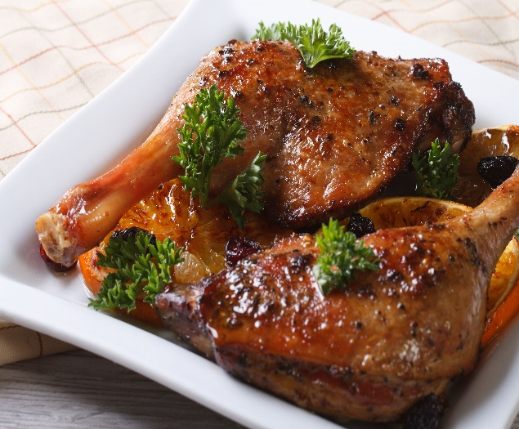

**Duck confit**

**Ingredient**

* 3 tablespoons salt
* 4 cloves garlic, smashed
* 1 shallot, peeled and sliced
* 6 sprigs thyme
* Coarsely ground black pepper
* 4 duck legs with thighs
* 4 duck wings, trimmed
* About 4 cups duck fat

PREPARATION

1. Sprinkle 1 tablespoon of salt in the bottom of a dish or plastic container large enough to hold the duck pieces in a single layer. Evenly scatter half the garlic, shallots, and thyme in the container. Arrange the duck, skin-side up, over the salt mixture, then sprinkle with the remaining salt, garlic, shallots, and thyme and a little pepper. Cover and refrigerate for 1-2 days.

2. Preheat the oven to 225°F. Melt the duck fat in a small saucepan. Brush the salt and seasonings off the duck. Arrange the duck pieces in a single snug layer in a high-sided baking dish or ovenproof saucepan. Pour the melted fat over the duck (the duck pieces should be covered by fat) and place the confit in the oven. Cook the confit slowly at a very slow simmer — just an occasional bubble — until the duck is tender and can be easily pulled from the bone, 2-3 hours. Remove the confit from the oven. Cool and store the duck in the fat. (The confit will keep in the refrigerator for several week.

**Own recipe**

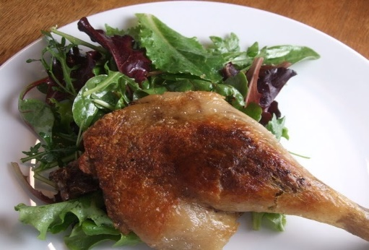

**Duck confit**

**Ingredients**

6 cumin seeds

12 coriander seeds

3 berries

50 gram flaky sea salt

6 duck leg and tight joints

1 small bunch thyme

1 rosemary branch

1 unpeeled garlic clove, sliced, plus 1 whole garlic blub, halved

About 500 gram goose or duck fat enough to totally submerge the duck legs

2 bay leaves

1 tsp black peppercorns

**Instruction**

1) The day before cooking, put the cumin and coriander seeds in a dry pan and toast until they are slightly coloured and aromatic. Remove to a board and crush them with the blade of a knife. Crush the juniper berries and mix with the species and the salt. Rub the mixture over the duck, scatter with thyme, rosemary and sliced garlic and chill for 24 hours, turning two or three times as they marine.

2) next day, heat the oven to 150C .wipe the duck with kitchen paper and pat dry, but don’t wash off the marinade.(the salt extracts the water from the meet cells, which will be inflated with fat as the duck cooks gentle .if you wash it, you will simply inflate the cells in water.

3) Put the duck in a cast-iron casserole and cover with goose fat or duck fat. Add the bay leaves and peppercorns and cook for about 2 ½ hours, or until the meat is almost falling away from bone. You can store the duck very simply by placing it in a pudding bowl, covering it with the fat and keeping it in the fridge; as long as it stay covered with fat it will last for weeks

4) To cook, remove the confit duck legs from their fat. Put an ovenproof frying pan on the stove until it is hot. Add the duck legs, skin-side down, and cook for 4 minutes .turn the legs and transfer the pan to the oven for 30 minutes, until crisp. Ready to serve.

**Conclusion**

A global cuisine is a cuisine that is practiced around the world. A cuisine is a characteristic style of cooking practices and traditions often associated with a specific region, country or culture. To become a global cuisine, a local, regional or national cuisine must spread around the world, its food served worldwide. There have been significant improvements and advances during the last century in food preservation, storage, shipping and production, and today many countries, cities and regions have access to their traditional cuisines and many other global cuisines**.**

**References**

Albala, Ken (2011). Food Cultures of the World Encyclopedia Greenwood. ISBN 978-0-313-37626-9

Zobel, Myron (1962). "Global cuisine: being the unique recipes of the 84 top restaurants of the world." Patron Press.

California Culinary Academy (2001). In the World Kitchen: Global Cuisine from California Culinary Academy. Bay Books (CA). ISBN 1-57959-506-5.

Cheung, Sidney; Tan, Chee-Beng (2007). Food and Food ways in Asia: Resource, Tradition and Cooking. Routledge. pp. 201–209. ISBN 0203947126

MacVeigh, Jeremy (2008). International Cuisine. Delmar Cengage Learning; 1st edition. ISBN 1-4180-4965-4.

Nenes, Michael F; Robbins, Joe (2008). International Cuisine. Hoboken, N.J.: Wiley, John & Sons; 1st edition. ISBN 0-470-05240-6.

Scarparto, Rosario (2000). "New global cuisine: the perspective of postmodern gastronomy studies." Royal Melbourne Institute of Technology.

Jump up ^ Cuisine (definition). Thefreedictionary.com. Retrieved June 2011.

Jump up ^ "Cuisine (definition)". Oxford Dictionaries. Retrieved 2013-05-26.

Jump up ^ "Fujian Cuisine. Archived July 31, 2013, at the Wayback Machine. Beautyfujian.com Archived July 10, 2011, at the Wayback Machine.. Retrieved June 2011.

Jump up ^ "Regions of Chinese food-styles/flavors of cooking." University of Kansas, Kansas Asia Scholars. Retrieved June 2011.

Jump up ^ "Eight Cuisines of China – Shandong & Guangdong." Travel China Guide. Retrieved June 2011.

Jump up ^ J. Li & Y. Hsieh. Traditional Chinese Food Technology and Cuisine. Asia Pacific Journal of Clinical Nutrition.

THE END